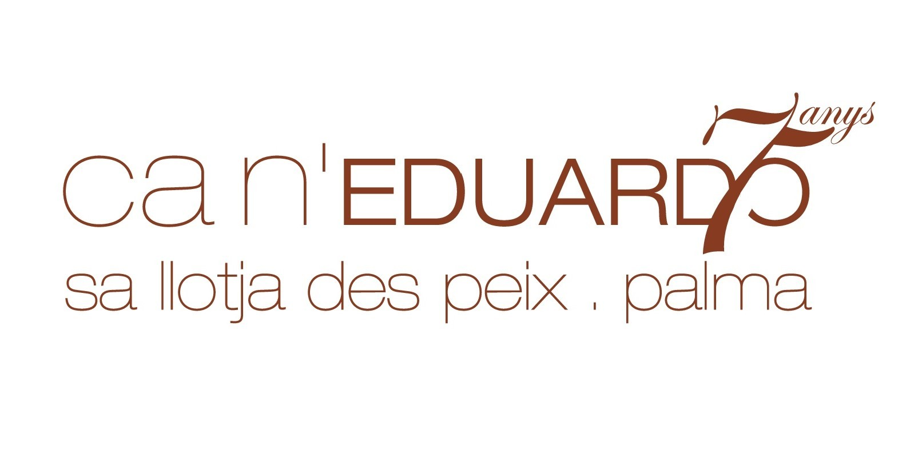

MENU for JOYRON FOUNDATION CHARITY DINNER
ON SATURDAY 29TH OCTOBER 2022

BREAD, OLIVES AND AIOLI

CREAMY SEAFOOD VOL AU VENT WITH PERNOD AND DILL
****
OR
GRILLED FILLET OF HAKE WITH GREEN ASAPRAGUS AND MUSHROOMS, TOMATO AND HERB SALSA
SEARED ENTRECOTE OF BEEF WITH ROAST SHALLOTS, ROSEMARY POTATOES AND TARRAGON MUSTARD
****
WARM CHOCOLATE VOLCANO, VANILLA ICE CREAM
****
VEGETARIAN/VEGAN and SPECIAL DIETARY REQUIREMENTS REQUIRE TO BE ADVISED IN ADVANCE
BEVERGES SERVED WITH DINNER UNTIL DESSERT

RAIMAT CLAMOR
RAIMAT CLAMOR ROSADO
VIÑA PACETA
ANNA DE CODORNIU
BEER
WATER
SOFT DRINKS
AFTER DINNER, DRINKS ARE ON A PAY BAR SERVICE.

